SAP HANA Migration, Unicode conversion and EHP Upgrade – SAP SRM
(Proof of Concept)

Contents:

1.Document History 2

2.Purpose 2

3.Background 2

4Tools Used 2

5.Preparations 2
5.1 Unicode Preparations 2
5.2 HANA database Preparations 4
5.3 EhP Preparations 9
5.4 DMO Preparations 9

6.DOM Execution 13

7.Post Processing 41

8.Backup and Restore 46

9. Bibliography 46

Document History
Revision | Date | Name | Remarks

Purpose
The purpose of this document is to describe the technical activities performed during HANA migration, Unicode and EHP upgrade for SAP SRM application.

Background
The sandbox system which was running on Oracle has been migrated to HANA along with the Unicode conversion and EHP upgrade.
Below table will provide the details of releases before and after migration.
 | Source | Target
Release | NW7.31 SPS06  EHP2 FOR SAP SRM 7.0  Kernel 721 PL201 | NW740 SPS05  EHP3 FOR SAP SRM 7.0  Kernel 741 PL26
Codepage | Non Unicode (1100) | Unicode (4103)
Database | Oracle (11.2.0.3.0) | HANA (Revision 72)
Operating System | Linux – App server | SUSE Linux - DB server  Linux – App server

Tools Used

EHP Upgrade, Unicode and HANA migration: SUM10 SP10 with DMO option.

Preparations

5.1 Unicode Preparations
Consistency Check for Cluster Tables
Run the report SDBI_CLUSTER_CHECK weeks before migration. It took 30mins in S36 system.
Conversion of customer-defined code pages
Run the report RSCP0126 and look for code page 9.No action is required in our case as there are no code pages starting with 9xxxx.
Remote Code Page Check
Run the report UMG_CHECK_RFC and check for the remote TCP/IP destination is consistent. In our case there are no inconsistent entries found.
Make ABAP programs Unicode-compliant
Detailed steps have been enclosed in the document.
Refer to DMO Guide for Unicode

Unicode Enhanced Syntax Check
Enable parameter abap/unicode_check=on in profile parameter.
Delete Matchcode IDs
Run report TWTOOL01.Check was successful. No action is required in this case.
QCM tables (Conversion Tables)
Goto SE14→Extras→Invalid Temp tables. There were no temp tables.
Restart SPUMG
Enter transaction SPUMG and Go to Scanner → Restart SPUMG.You will see the below screen.
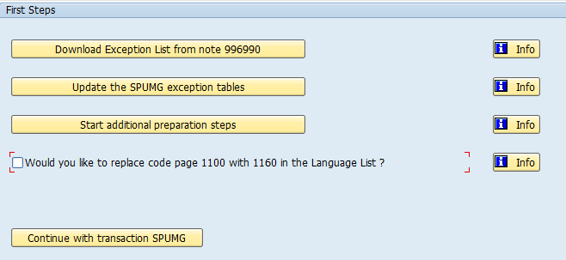
Click on download exception list and download xml file from note 996990.
Click on second option “update the SPUMG exception tables”.Here it will ask you to provide xml file which is downloaded in the first step.
Click on “start additional preparation steps”.On the next screen reports are displayed in gary colour.Choose background.All reports will be executed in background.
Look for reports which are other than green.In our case,there were some reports which are in other than green but those are releated to component SAP_APPL.Since we are not using this component, we have ignored.
Click on Continue with transaction SPUMG.
In the next screen Select Scanner → Initialize → Worklist.
Select Schedule Worker Jobs and select immediately.
Check if tables with status ‘Error’ exist. In our case no errors have been observed.

5.2 HANA database Preparations
Create database in HANA server:
Start Lifecycle management and select Add SAP HANA System.
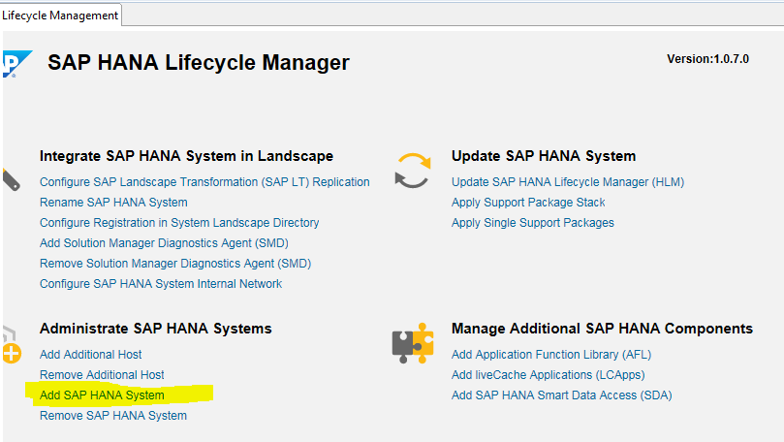

Provide the path for DVD.

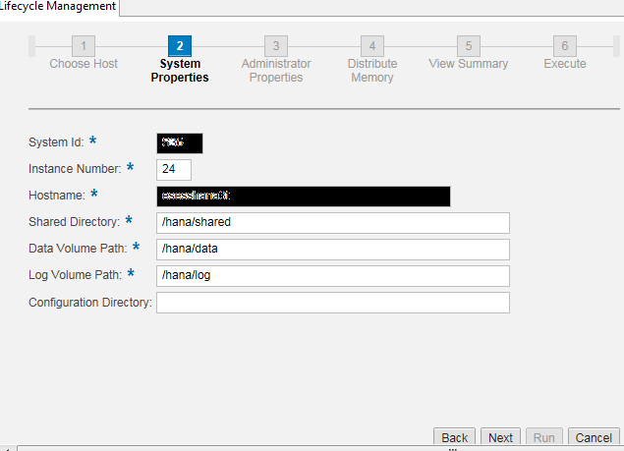
Provide the details as above.
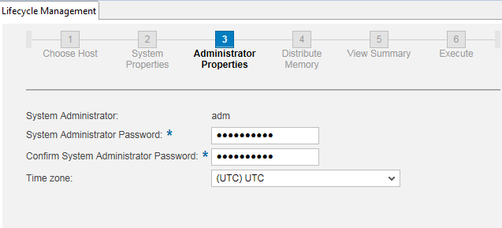
Applying database updates through HANA studio:
Generate stack file for HANA database from Service market place.
Goto the below location and click on Support pack stack download.
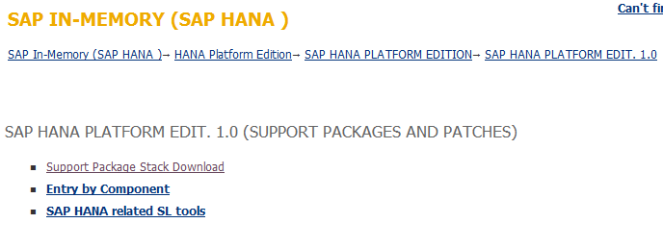
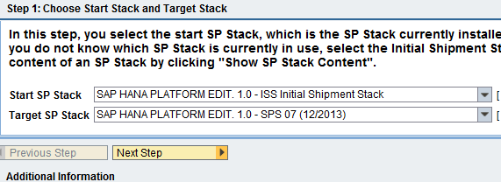
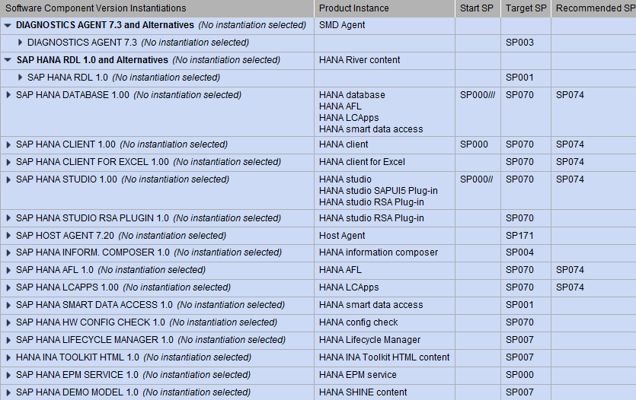
Enter next and click on Generate stacl XML file and add required files to download basket.
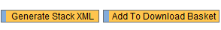
Login to studio and right click on Lifecycle management as below.
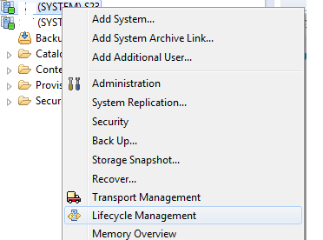
Provide sidadm credentials. Now you will get below screen.
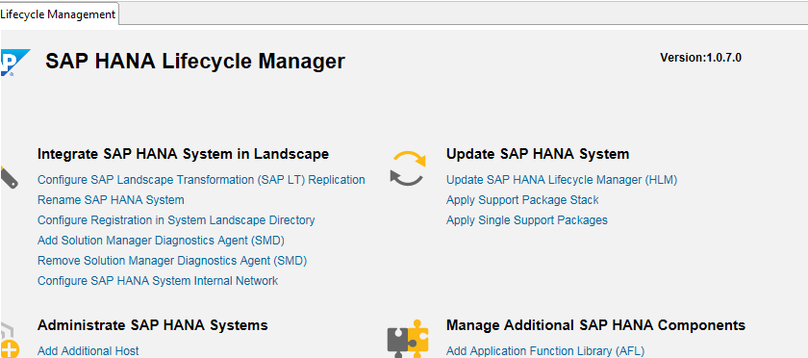
Click on Apply Support package stack.
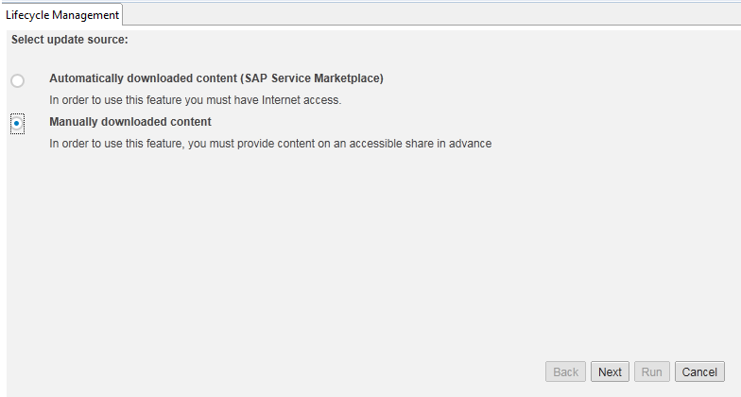
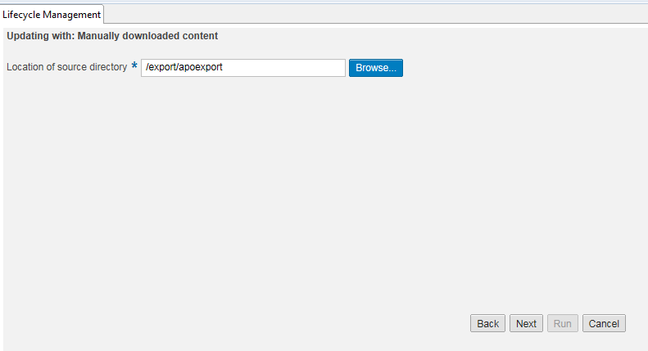
Provide the location of stack and downloaded directory.Click on Next.
It will give you the summary and click on next.
After that it will update the HANA studio,HANA client,HANA revision to the latest version as per the stack file generated.

Install HANA client in HANA server and in CI server:
- Download HANA client from service market place.
- Upload the HANA client and uncar using SAPCAR –xvf.
- Goto directory SAP_HANA_CLIENT and execute hdbinst.
- You will get below screen and provide the installation path.
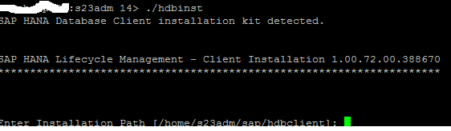
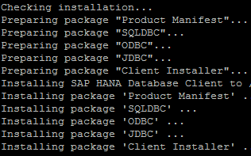
- Client instalaltion has been completed.

5.3 EhP Preparations
- Generate stack file for NW and EhP upgrade from solution Manager.
- Place the downloaded files in to download directory.
- Update new kernel files in the existing kernel directory.(R3trans,tp,R3load,R3chk).
- Make sure that we have enough free size in trans and SUM directory.

5.4 DMO Preparations
- Run the below command one or two weeks before migration.
brconnect -u / -c -f stats -o <schema_owner> -t all -f allsel,collect,space –p 8
- Look for below note for latest updates and implement notes as per the SAP note
1921023 - SMIGR_CREATE_DDL: Corrections and enhancements for SAP HANA
- Run the report SMIGR_CREATE_DDL.
SE38: SMIGR_CREATE_DDL
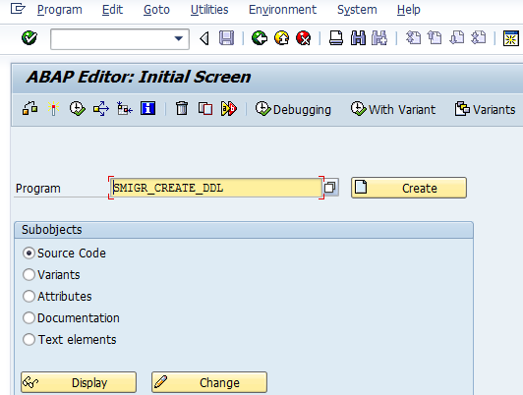

F8 / Execute
Subdirectory SQL_FILES was created in /tmp upfront.
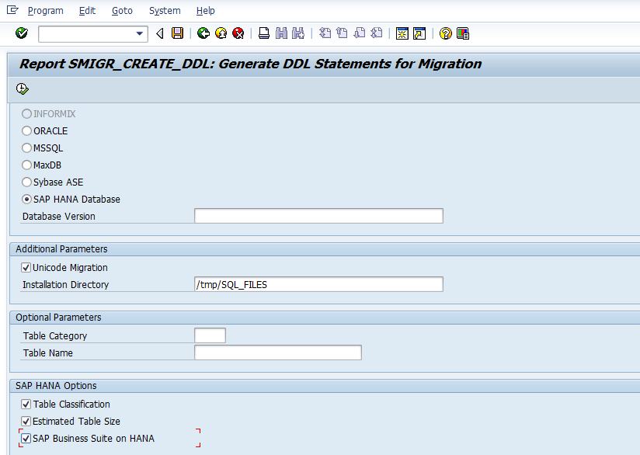
F9 / Execute in Background
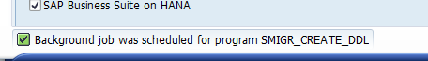
Result
Job has been completed successfully.
Perform the below steps once you are ready with the migration.
SPUMG updates
Enter transaction SPUMG and Scanner → Worklist → Update Worklist.Check for any error messages.
Check Matchcode IDs
Run report TWTOOL01 again to check whether there are still existing active matchcode IDs. There were no active matchcodes observed.

Nametab handling
In SPUMG select Extras → Unicode Nametabs → Create Unicode Nametabs from the menu.
Note: Do not import new DDIC objects or modify existing DDIC objects after you have created the Unicode nametabs and before the export of the database! Otherwise the nametabs will become invalid!
Observed below inconsistent objects in the Unicode nametab.
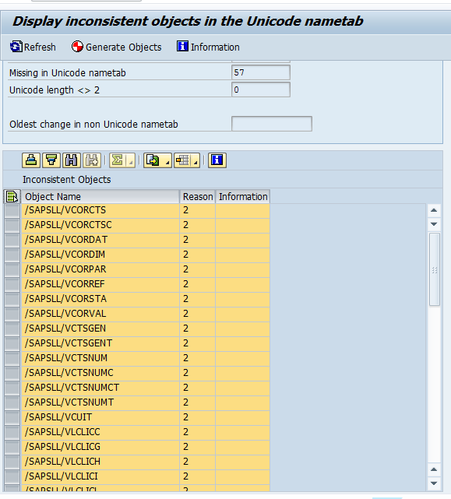
These are not in use and cannot be activated. Perform below steps to delete the above inconsistent objects.
The change document objects can be checked with report RSSCD_CHECK_OBJECT
Use report RSSCD_CONS_OBJECTS to delete these inconsistencies.
Please see also notes 1593470 and 1675352.

Additional Downtime Steps
Make sure that the system is in business downtime now, i.e. no users should be working in the system. Then go to SPUMG menu → Extras → Additional Downtime Steps.
Report UMG_ADD_DOWNTIME_STEP will be executed. Select all reports and click on background. All reports will be executed automatically in sequential order. All reports will turn to green.
Check the number of entries in table UM4STATUS.If there are no values create them as below.
Insert into UM4STATUS values ('0','731','740','S','20140318','000000');
Insert into UM4STATUS values ('1','731','740','S','20140318','080000');
Insert into UM4STATUS values ('4','731','740','S','20140318','120000');
Then call report UMG_FINISH_PREPARATION and run through the 3 steps one by one.
Check again the entries.
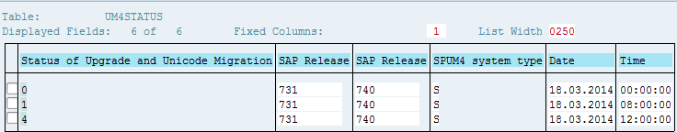
Run the report UMG_SHOW_UCTABS and make sure that there are no inconsistent objects in the Unicode nametab.

Set Environment variable
Export SUPPORT_DECLUSTERING=false
Export HDB_MASSIMPORT=YES

DOM Execution
SUM tool needs to be triggered from /usr/sap/S36.Due to space issue we have created SUM directory in sapdata1.After that created softlink towards /usr/sap/S36.
Run the SUM as mentioned below:
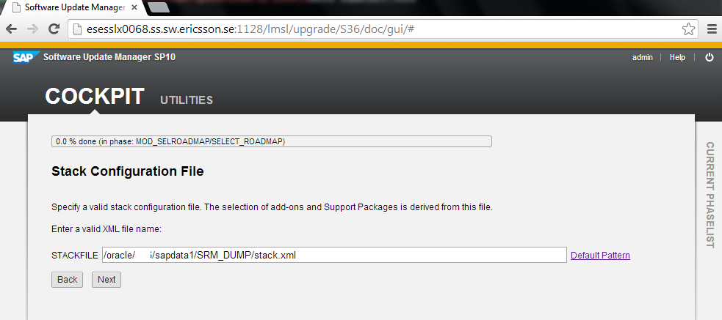

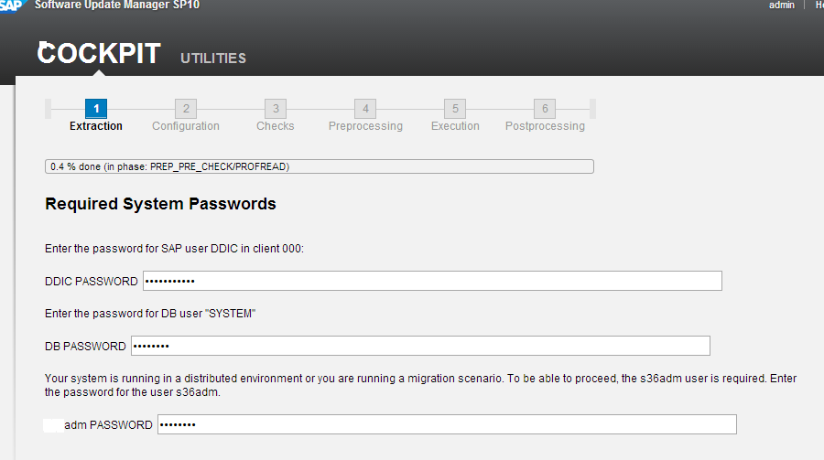

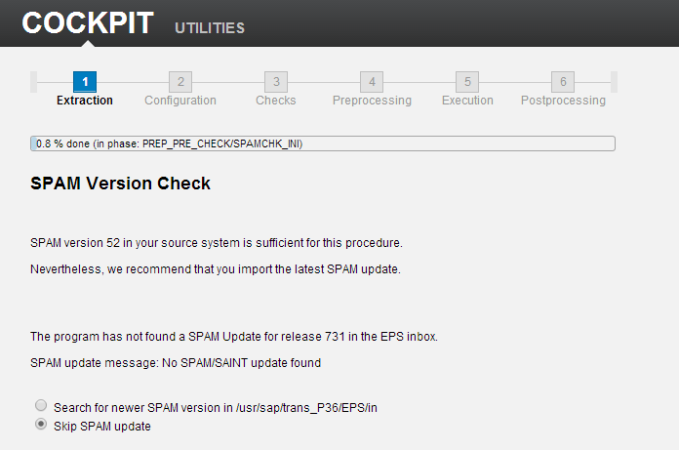
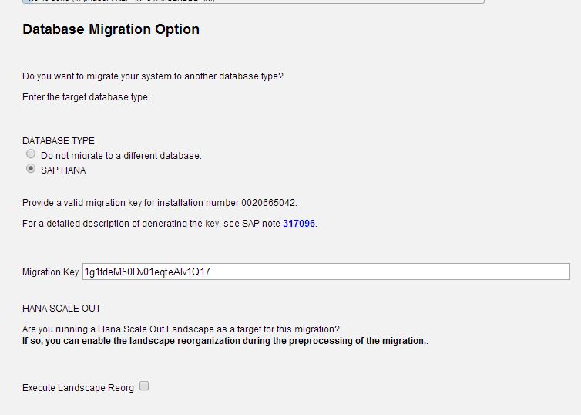
Generate Migration key from Service Market Place.
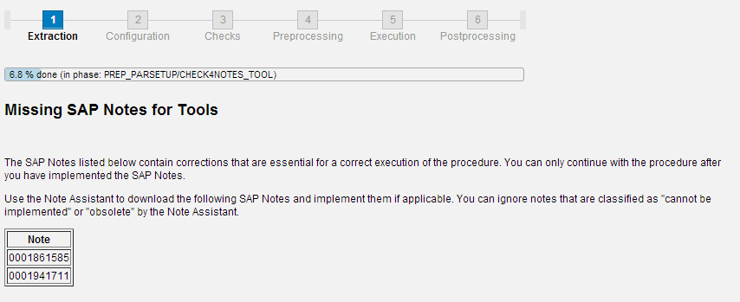
Implement above notes through SNOTE.
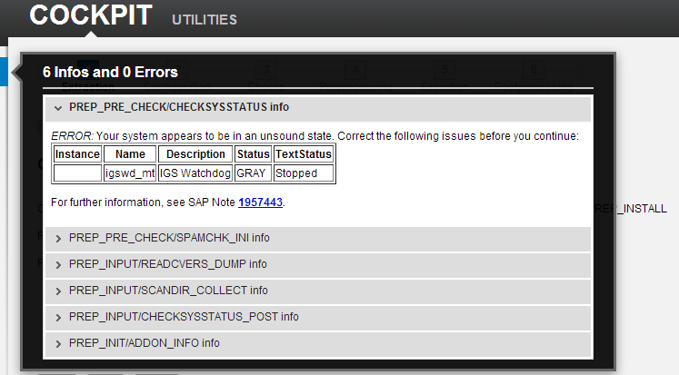
Aboreted with error – igswd with GRAY.
1957443 - Check for system status at upgrade preparation (phase CHECKSYSSTATUS)
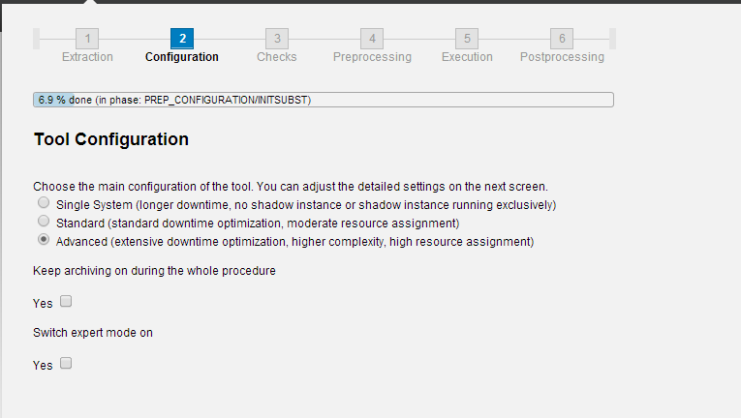

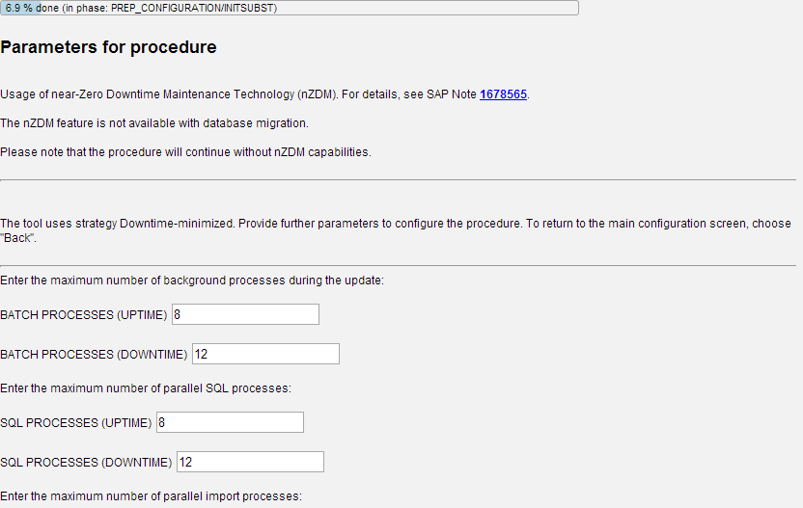
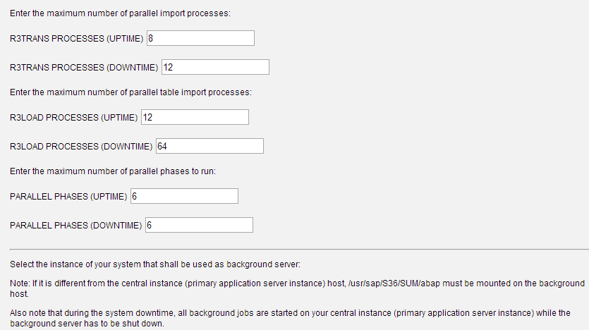
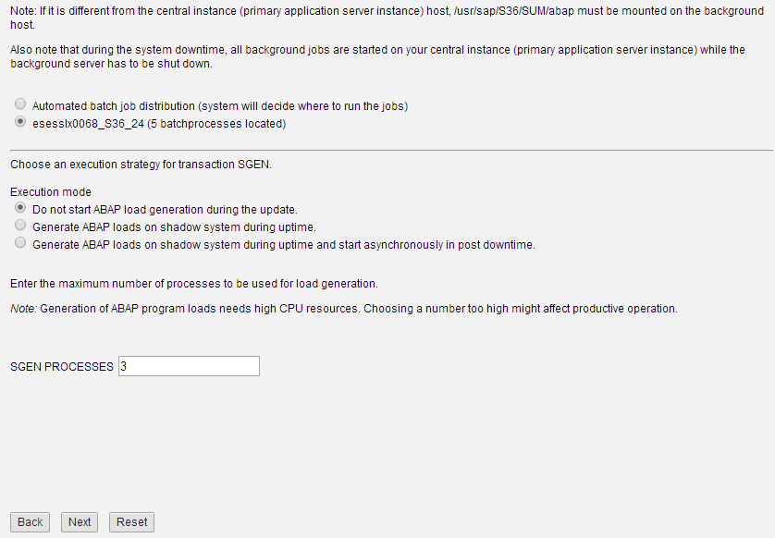

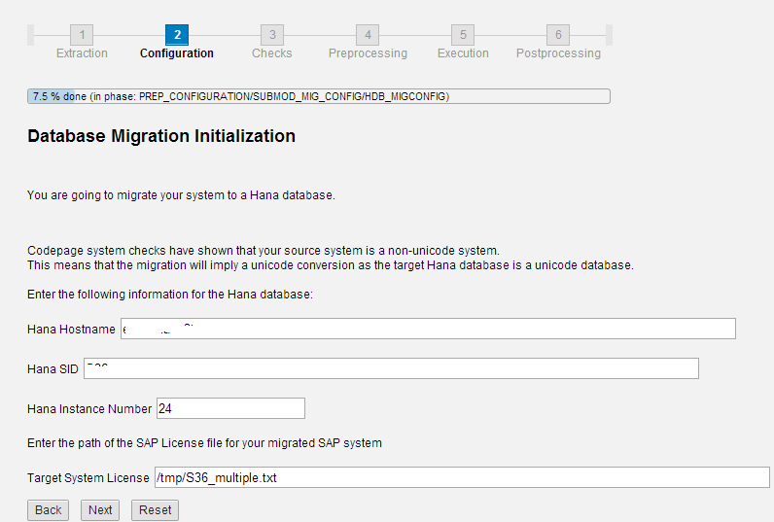

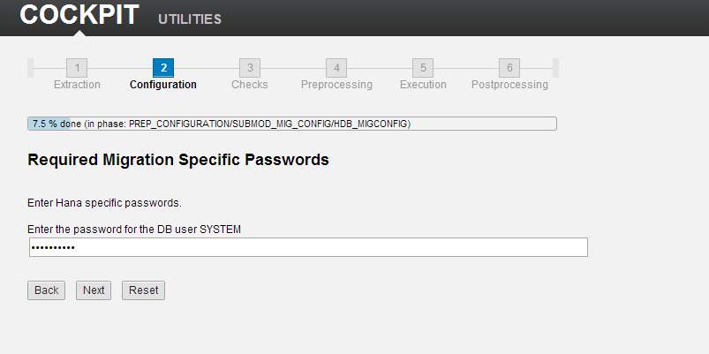

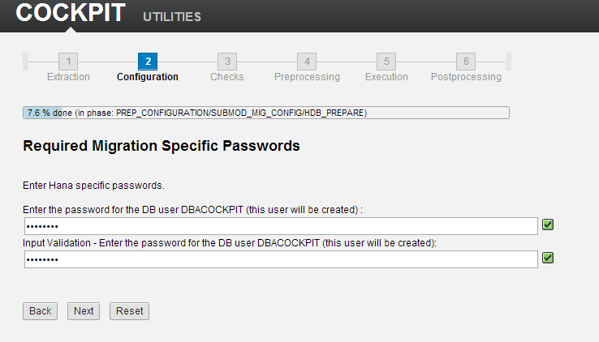

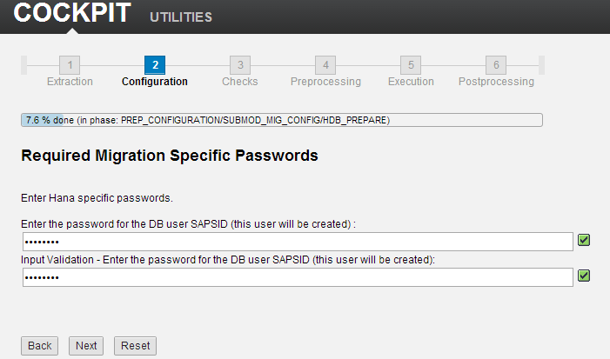
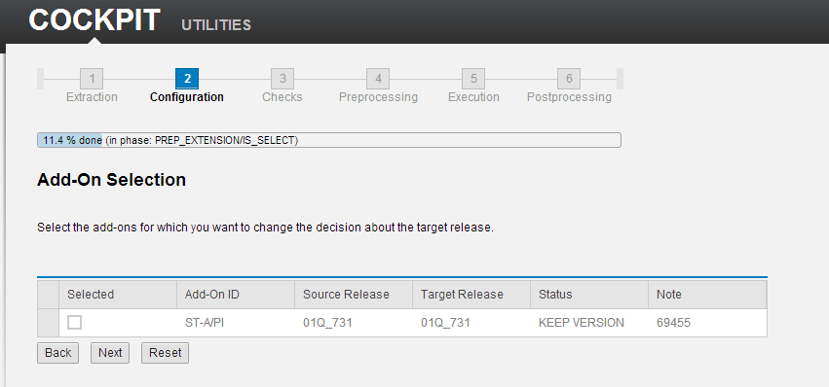

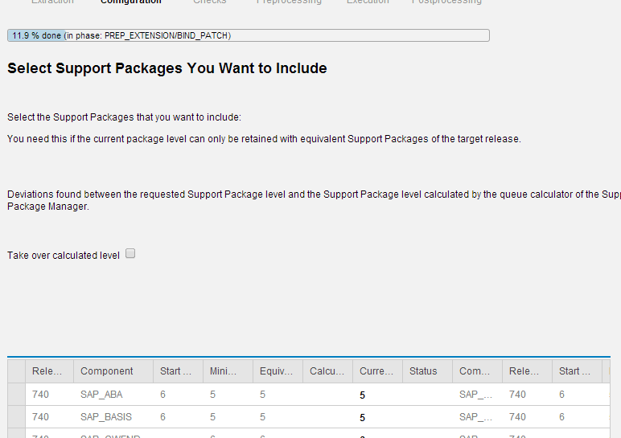
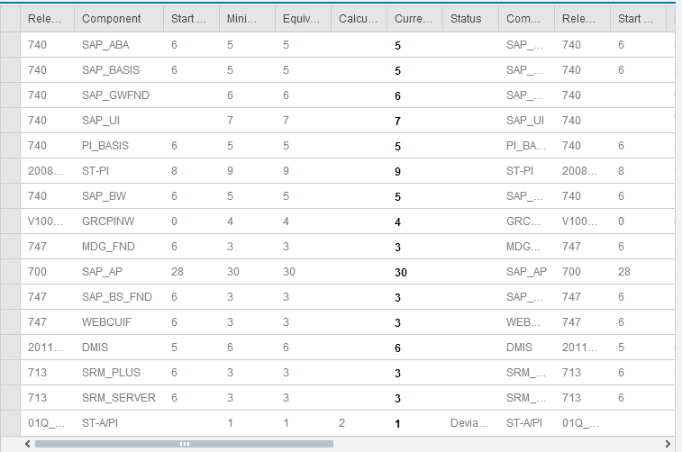
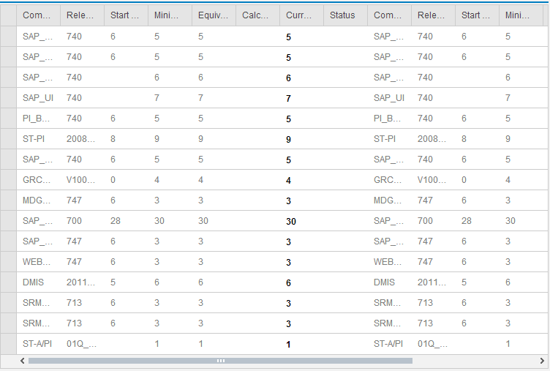
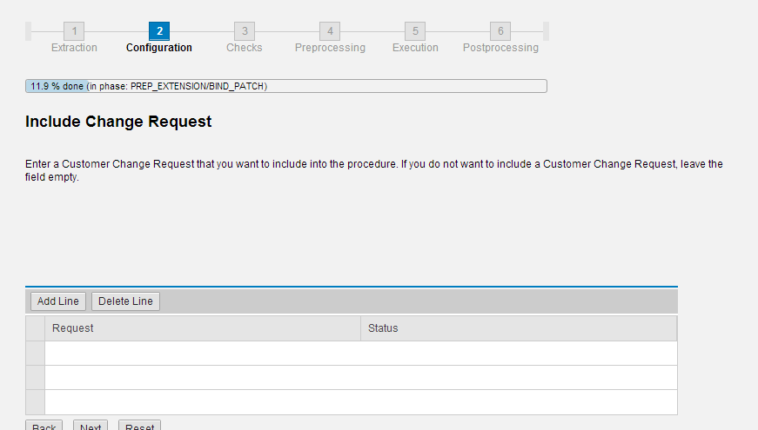

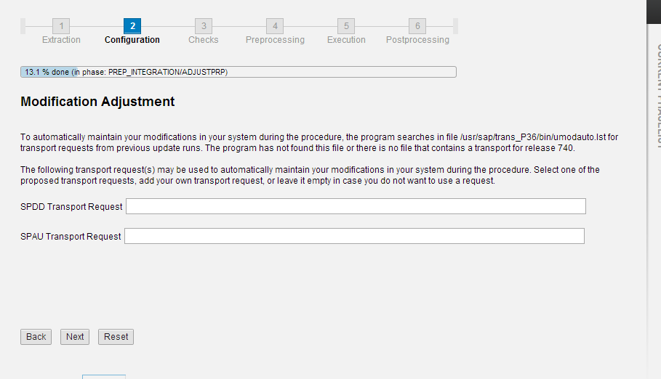

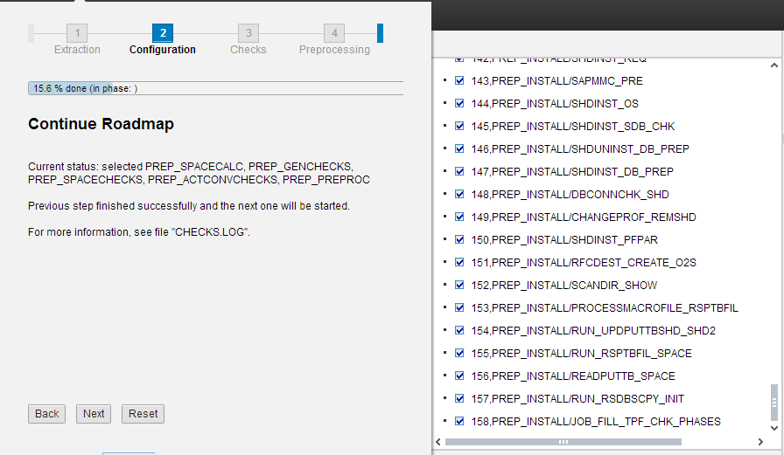

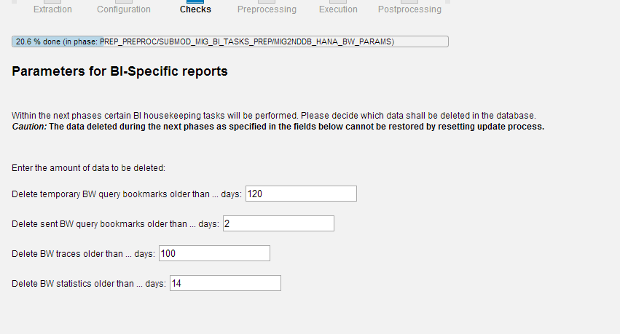

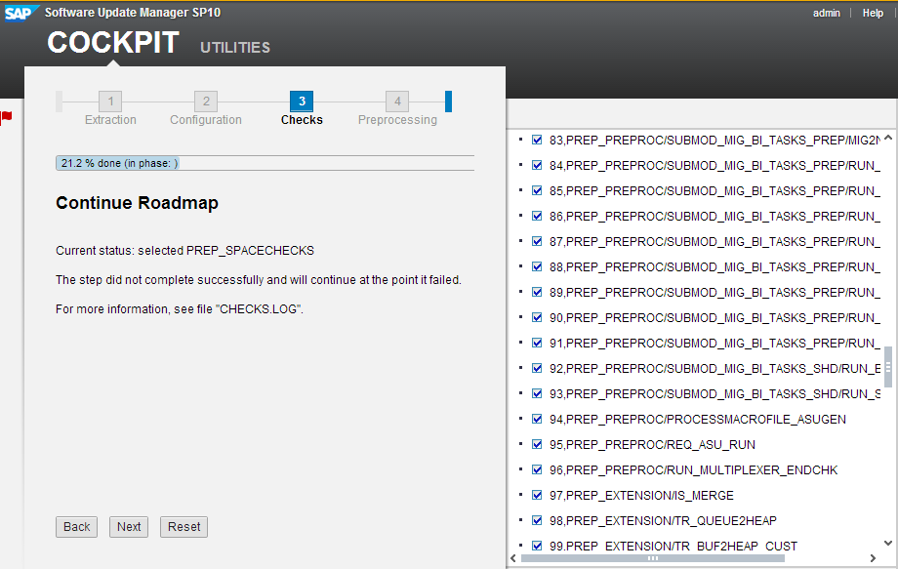

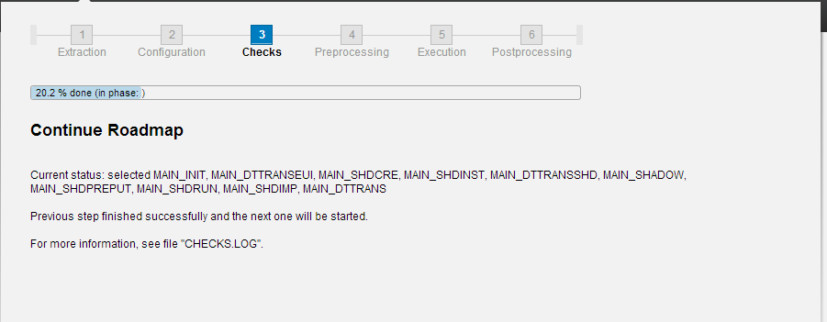

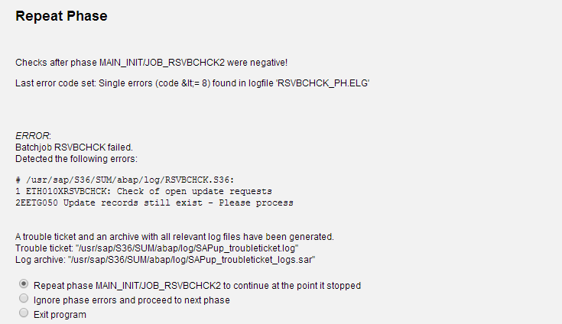
Delete old update records and continue.
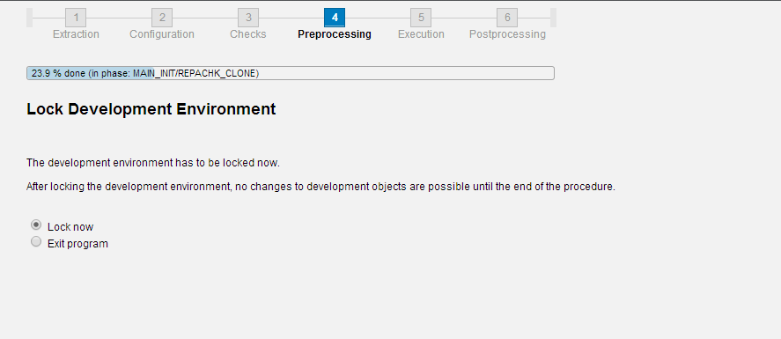

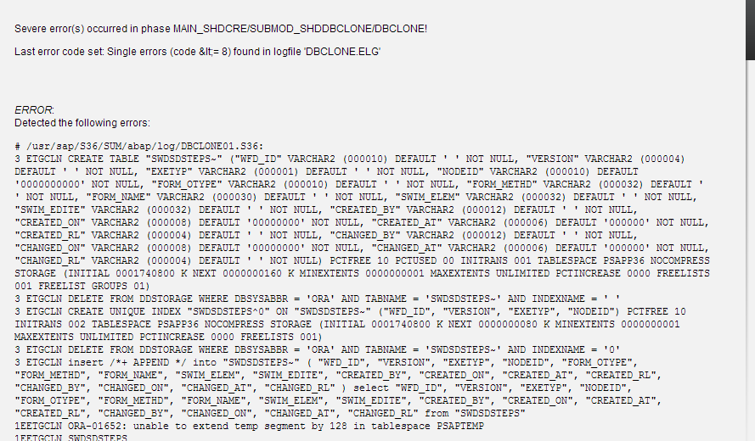
Extend PSAPTEMP to 50GB and continue.
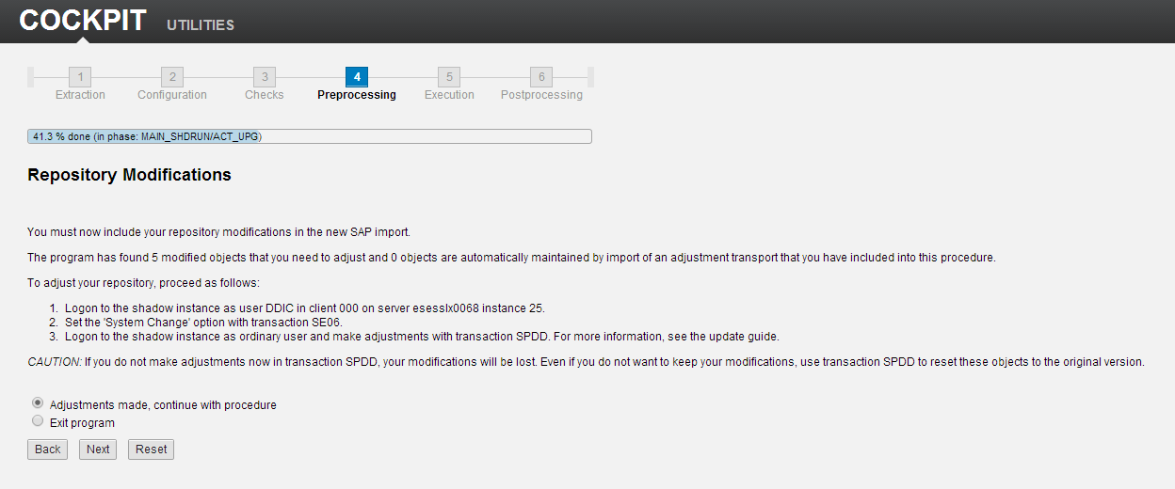

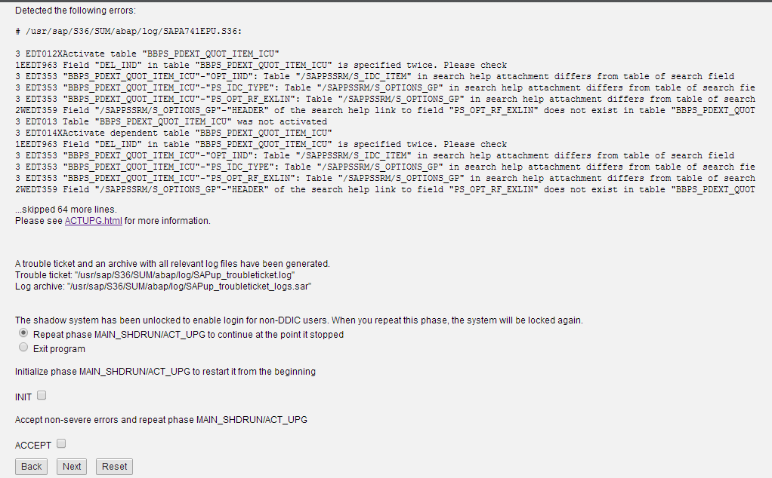
Perform the steps as mentioned in the note 1835882.
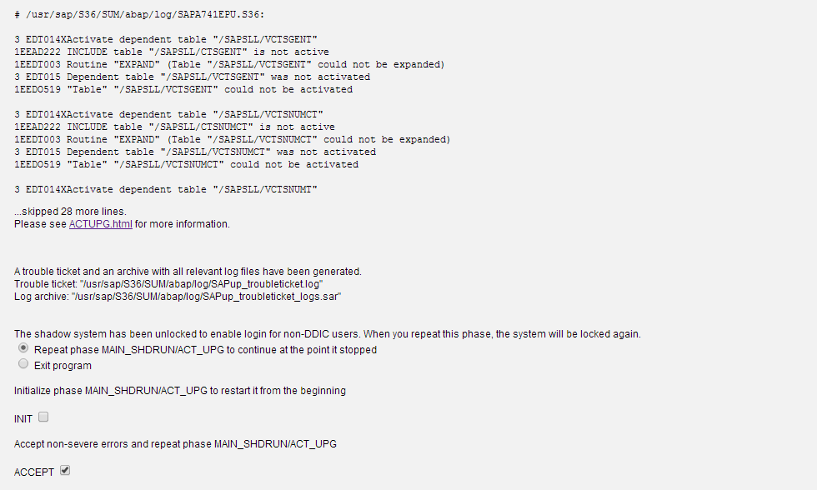

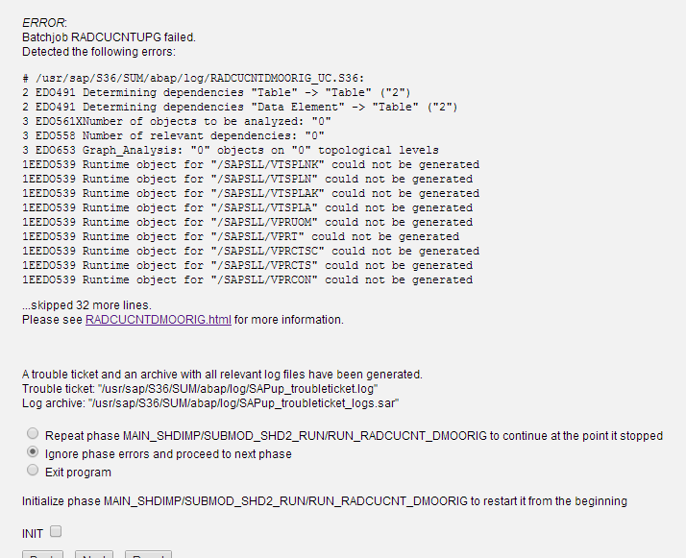
Set the breakpoint at this phase to ignore the /SLL* errors.This will not happen in next migration as we are planning to delete all inconcistencies.
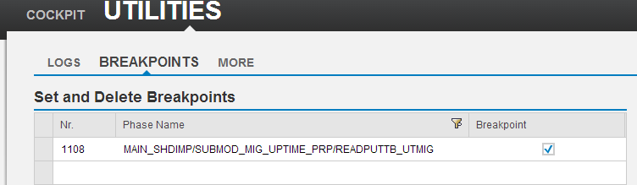

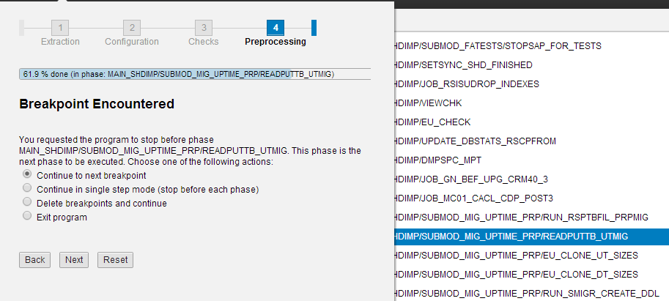

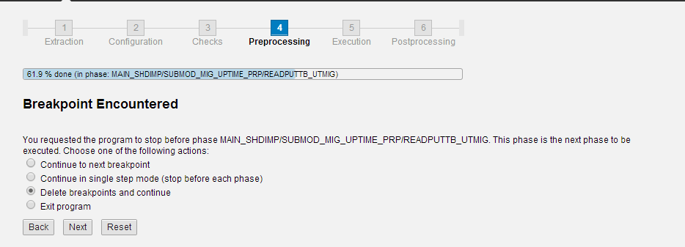

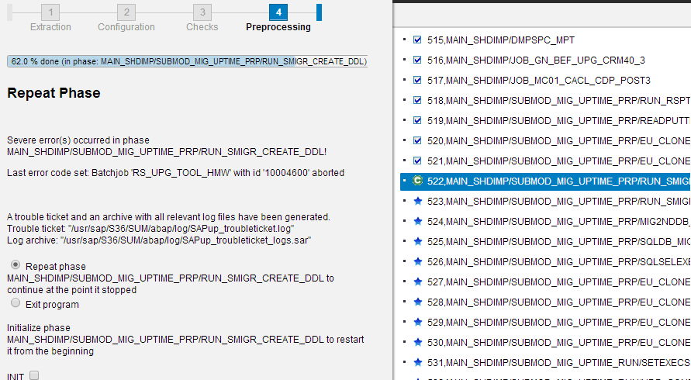
Failed with DUMP DBIF_RSQL_SQL_ERROR.
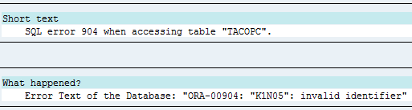
Delete and recreate tables CLU4 and VER_CLUSTR through Se14.
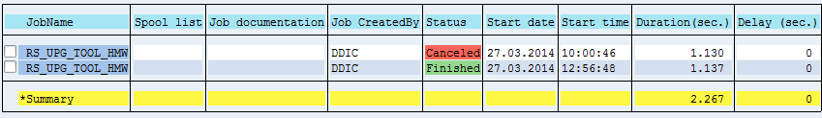
At the below phase table spliting will happen.
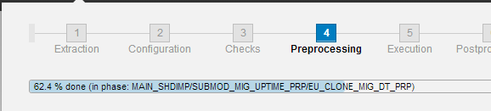

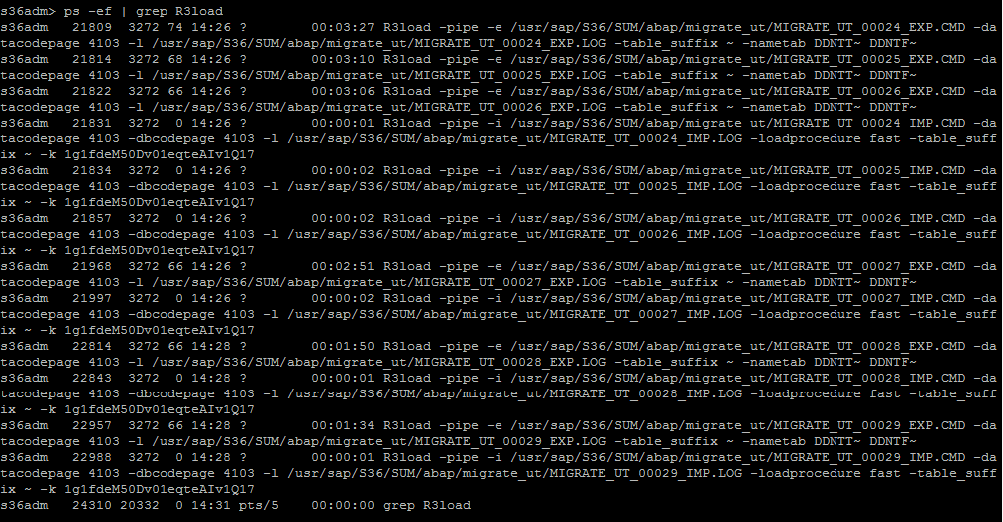

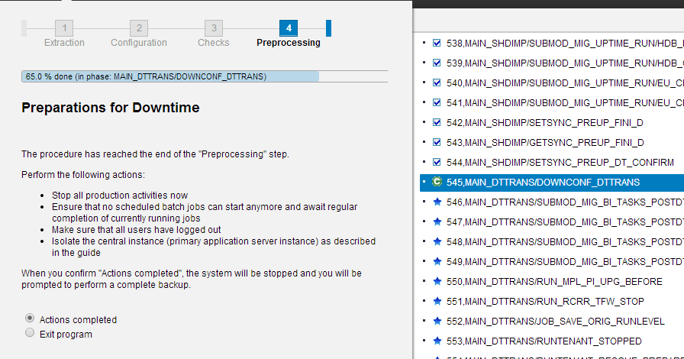
Isolate the system before entering into the downtime phase.
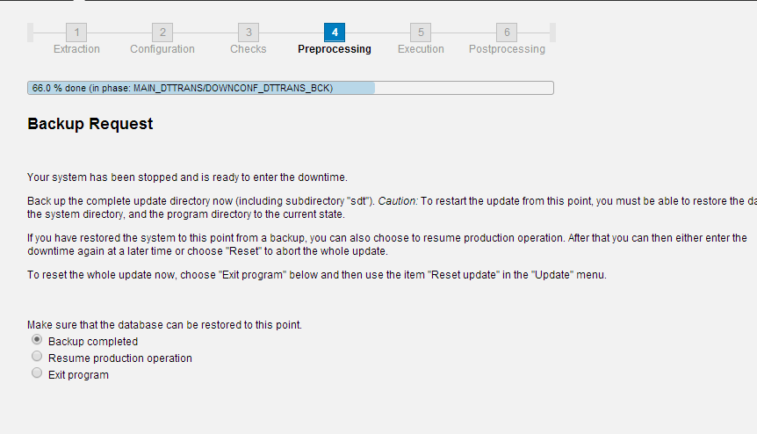
Disbale archive log.
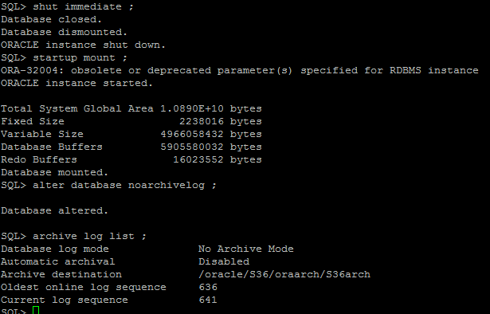

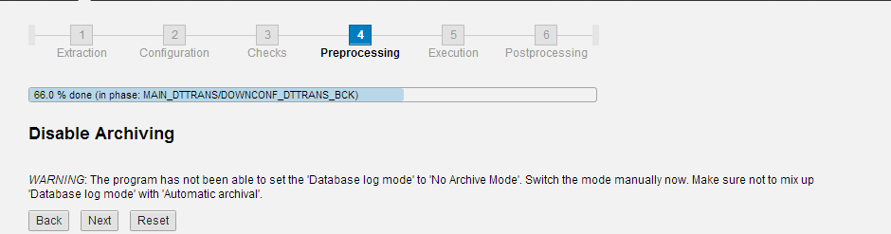

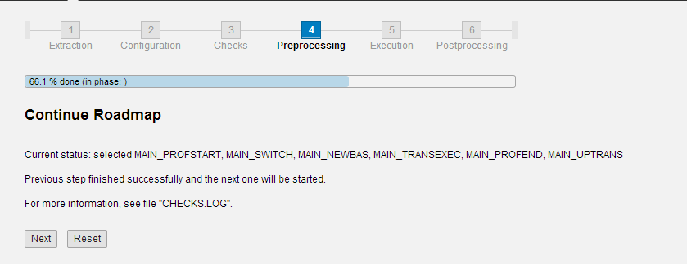

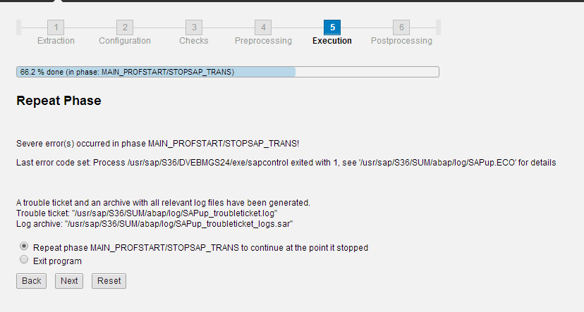
Start sapstartsrv with the below command.
/usr/sap/S36/DVEBMGS24/exe/sapstartsrv pf=/sapmnt/S36/profile/S36_DVEBMGS24_xxx –D
To increase the no.of processes on fly.
Cd /usr/sap/S36/SUM/abap/bin/SAPup set procpar gt=scroll
Issue: Error while starting the system on target.
Sol: Updated kernal with latest patch.
Perform the below settings as described in the note at phase XPRAS_AIMMRG.
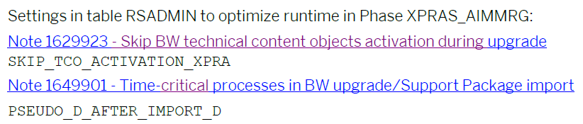
Issue: BAdi deactivation.
Sol: deactivated the badis through SE18.
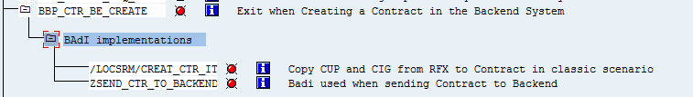
Issue:
2, No such file or directory, [/bas/741_REL/src/ccm/sapstart/sapxxcpe.c:2489]
Sol: Set the permissions of file sapstack to sidadm instead of root (in kernal directory)

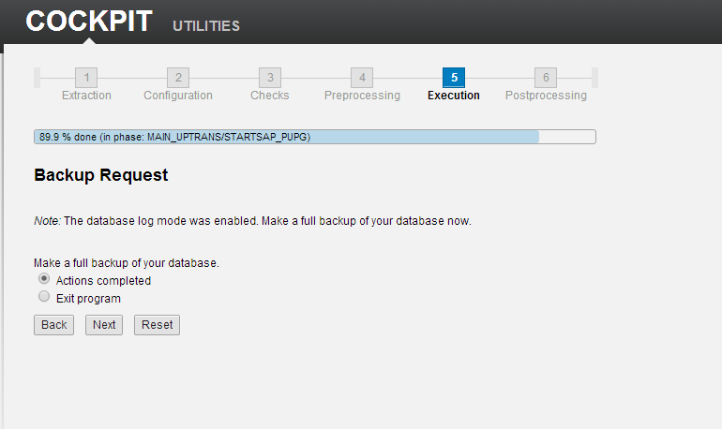
Trigger the backup through HANA studio.
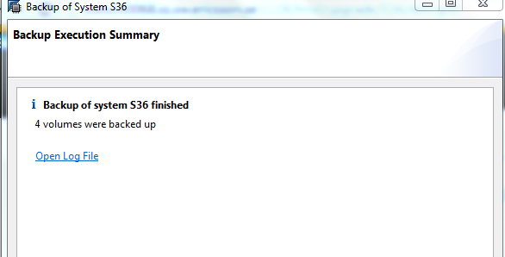

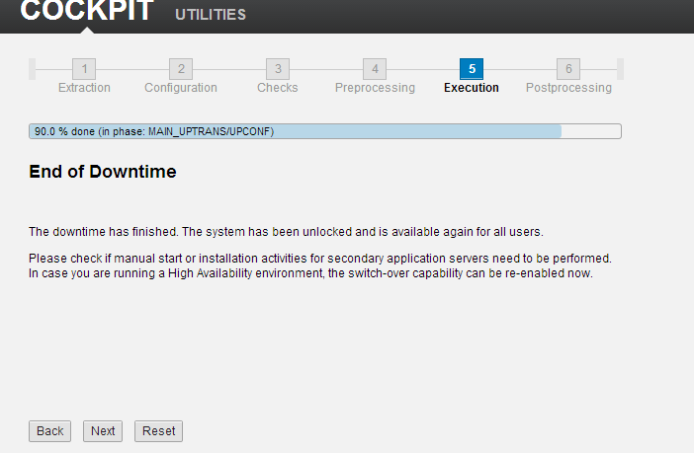

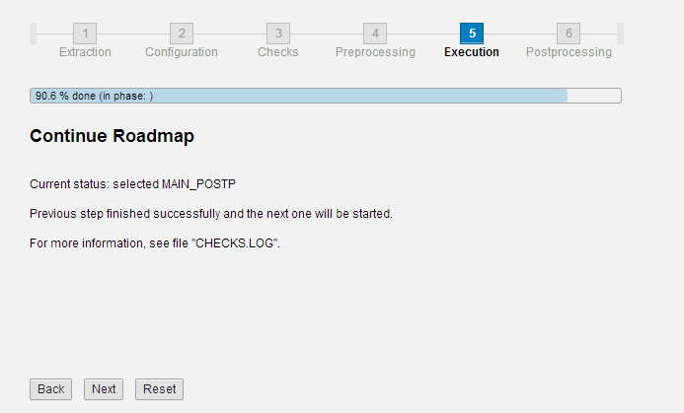

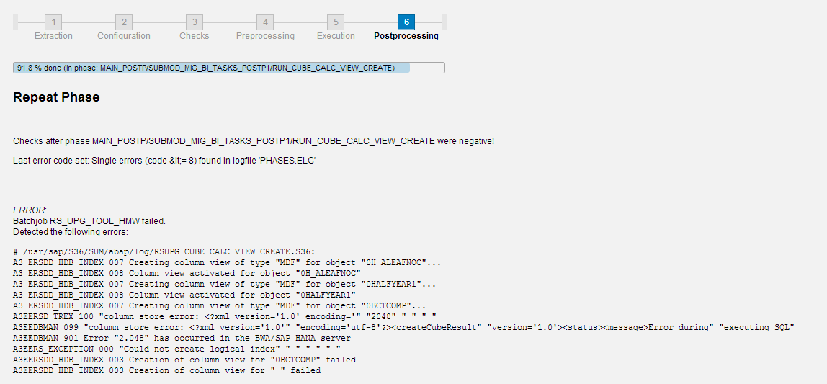
Sol: Do the chnages as per the below note.
1695112 - Activities in BW after migrating to the SAP HANA database.

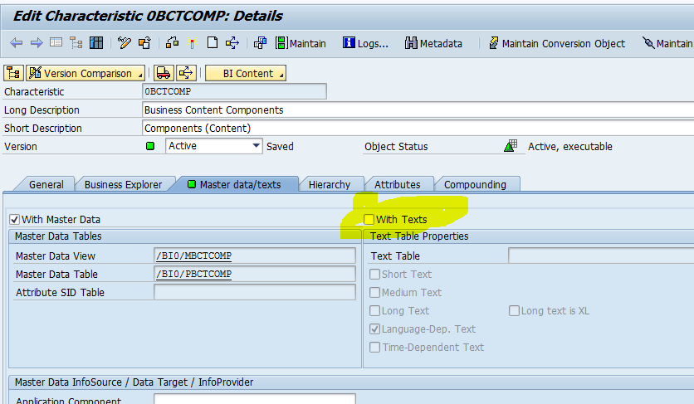

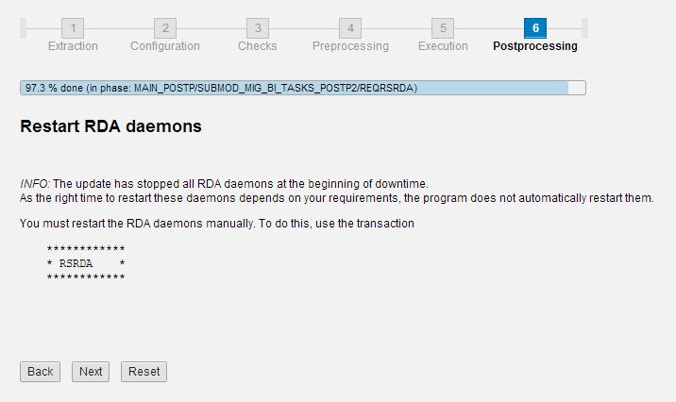

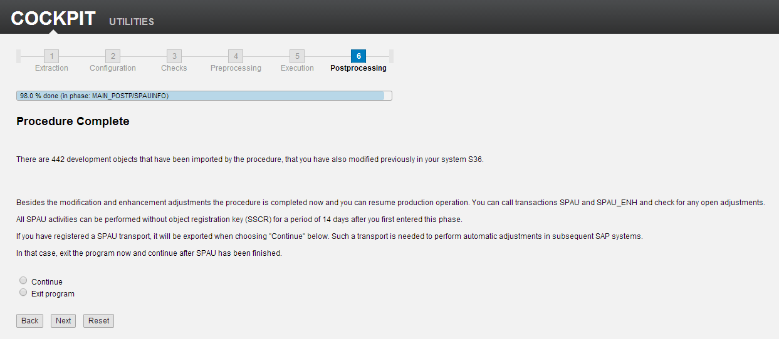

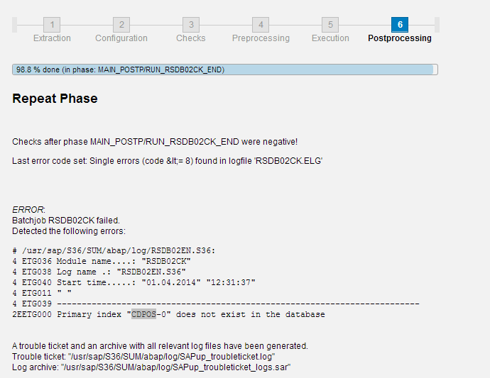
Primary key was not created after migration and this is included in next migrations.
Workaround to create primary index CDPOS~0 on S36:
1) create table CDPOS_1 in schema SAPP36 with same structure as CDPOS
2) create primary index on CDPOS_1
3) copy data from CDPOS to CDPOS_1
4) drop CDPOS
5) rename CDPOS_1 => CDPOS
SQL statements:
1)
CREATE COLUMN TABLE "SAPP36"."CDPOS_1"
("MANDANT" NVARCHAR(3) DEFAULT '000' NOT NULL ,
"OBJECTCLAS" NVARCHAR(15) DEFAULT '' NOT NULL ,
"OBJECTID" NVARCHAR(90) DEFAULT '' NOT NULL ,
"CHANGENR" NVARCHAR(10) DEFAULT '' NOT NULL ,
"TABNAME" NVARCHAR(30) DEFAULT '' NOT NULL ,
"TABKEY" NVARCHAR(70) DEFAULT '' NOT NULL ,
"FNAME" NVARCHAR(30) DEFAULT '' NOT NULL ,
"CHNGIND" NVARCHAR(1) DEFAULT '' NOT NULL ,
"TEXT_CASE" NVARCHAR(1) DEFAULT '' NOT NULL ,
"UNIT_OLD" NVARCHAR(3) DEFAULT '' NOT NULL ,
"UNIT_NEW" NVARCHAR(3) DEFAULT '' NOT NULL ,
"CUKY_OLD" NVARCHAR(5) DEFAULT '' NOT NULL ,
"CUKY_NEW" NVARCHAR(5) DEFAULT '' NOT NULL ,
"VALUE_NEW" NVARCHAR(254) DEFAULT '' NOT NULL,
"VALUE_OLD" NVARCHAR(254) DEFAULT '' NOT NULL ) UNLOAD PRIORITY 5 AUTO
MERGE WITH PARAMETERS ('PARTITION_SPEC' = 'HASH 15
MANDANT,OBJECTCLAS,OBJECTID,CHANGENR');
2)
ALTER TABLE "SAPP36"."CDPOS_1" ADD PRIMARY KEY ("MANDANT", "OBJECTCLAS",
"OBJECTID", "CHANGENR", "TABNAME", "TABKEY", "FNAME", "CHNGIND");
3)
insert into "SAPP36"."CDPOS_1" select * from "SAPP36"."CDPOS";
4)
drop table "SAPP36"."CDPOS";
5)
rename table "SAPP36"."CDPOS_1" TO "CDPOS";
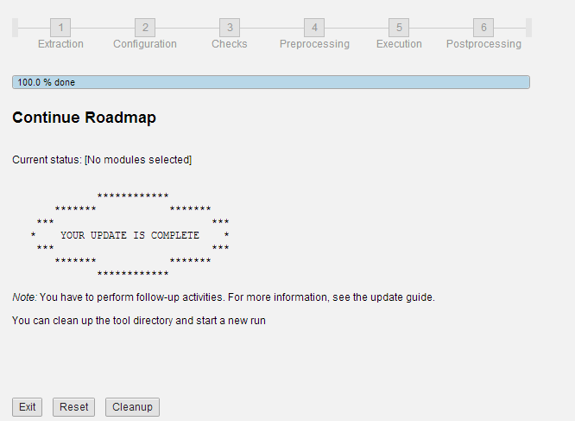

Post Processing
- UC Postprocessing as per UC guide
Additional Post Conversion Steps
Run the Report UMG_ADD_POST_STEP. On the next screen the included reports are displayed. Start all reports in background.
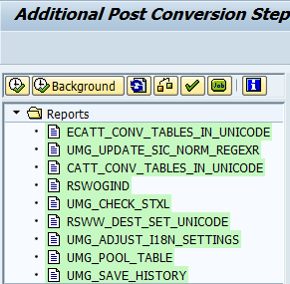
Run the report UMG_FINISH_PREPARATION.
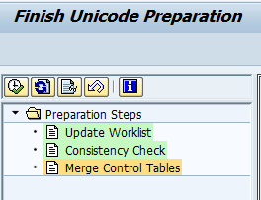
Adapt SAP system profile parameters (Note 790099)
Remove the following profiles from instance or default profiles.
install/codepage/appl_server
abap/unicode_check

RFC Destinations
Go to transaction SM59, open tree TCP/IP connection, choose a connection and press pushbutton Change from the taskbar.
Select tabstrip MDMP & Unicode. In dialog box Communication Type with Target System select radio button Unicode. Save the settings.
When the destination is a Unicode system you should set Communication Type with Target System) to Unicode.
When the destination is a non-Unicode system you should set Communication Type with Target System) to non-Unicode.

TMS RFC connections after the Unicode Conversion:
Run the report RSTMS_UNICODE_FIX (Note 935239)

Secondary Indexes for the business suite on HANA (Note 1794297):
Run the report SHDB_INDEX_ANAYZE to give us the list of missing indexes.
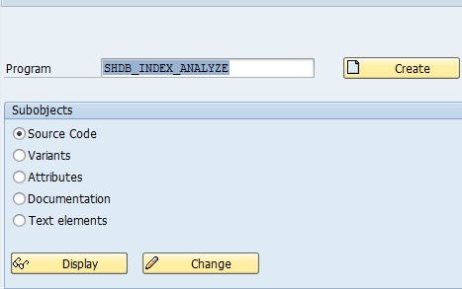
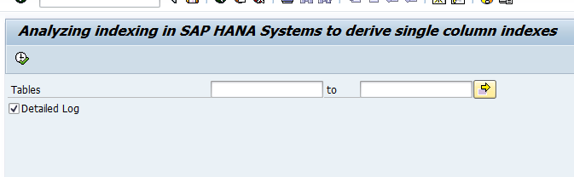
It will give list of indexes needs to be created.
Create them as below.
Run the report SHDB_INDEX_CREATE to create missing indexes.
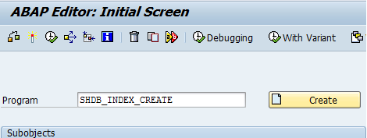
Execute.
In the next step,provide the request number which is created during analysis and list of indexes needs to be created.
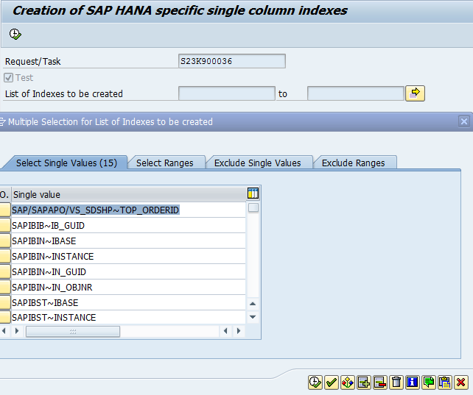
Applying License for application and HANA database.
Update the details in SMP for application and apply through SLICENSE.
For HANA database,we need to create new enty with same SID as below. (Don’t modify the existing SID for HANA license).
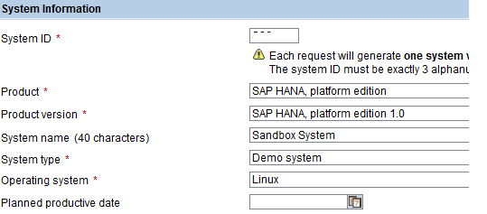
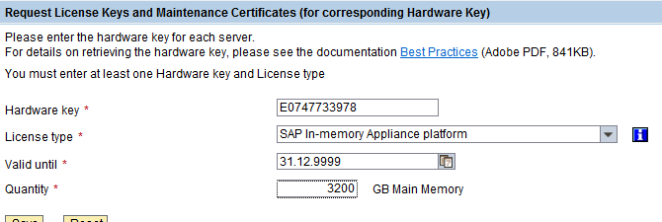
Once this entry has been added,request for license in SMP it self.
Once you have received mail,apply the same through studio.
Follow the below steps to perform the same.
Right click on properties.
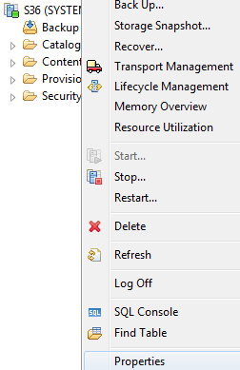
Click on License.
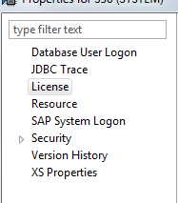
Click on Install License Key.
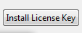
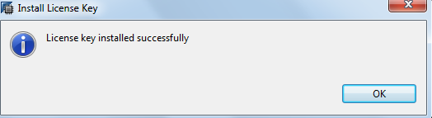
We can see permanent license in the same area.
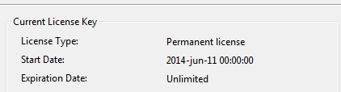

Backup and Restore
8.1 Backup Procedure:
As per process to take backup
8.2 Restore Procedure:

Bibliography:

Unicode document:
https://service.sap.com/sap/support/notes/1968508

Unicode FAQ’s:
https://service.sap.com/sap/support/notes/1322715

EHP3 upgrade (Release Note):
https://service.sap.com/sap/support/notes/1818517

Database Migration Option (DMO) of SUM – Introduction
http://scn.sap.com/docs/DOC-49580

Software Update Manager 1.0 SP10
https://service.sap.com/sap/support/notes/1878193

